**First Aid Team Exercise**

**Date: _____________**

**Time:_____________**

First Aid Team Exercises will follow all applicable requirements specified in the **Company Name Contingency Emergency Action Plan:**

**5.6-Gate Keepers**

**5.10-First Aid Responders**

**7.4-Severe Injury**

**7.8-Medical Emergencies**

**7.11-First Aid Emergencies**

**Shift: _____________**

**Location: _______________**

**Participants:**

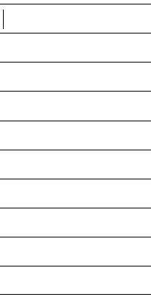

**Goals and Discussion:**

•What did you learn during the exercise?

•What worked well?

•What were the gaps in our exercise that need to be addressed? **(List all gaps on this form).**

•Are there any policies or procedures that need to be revised or further developed?

•Any additional training or resources we need to provide to the team?

**Supervisors and Management on shift are required to be to be notified of the exercise occurring before the exercise takes place.**

**Exercise Scenario:**

An employee is observed laying on the floor and is having violent jerking movements of their arms and legs and stiffening of the body. A co-worker in the breakroom stated that they just collapsed and fell onto the floor while sitting in their chair.

**Begin to Activate the Emergency Action Plan Now:**

Time drill started: __________

Time employee discovered:____________

Actions taken during the seizure:____________________________________________________________________________________________________________________________________________________________________________________________________________________________________

Time 9-1-1 was called (9-1-1 call):______________

Time AED sent for:_____________

Time AED arrived:_____________

Time external facility entrance gates opened for EMS:______________

Time freight and passenger elevator opened for EMS:______________

Time designated person is sent to wait for EMS outside building:____________

Actions taken after the seizure:____________________________________________________________________________________________________________________________________________________________________________________________________________________________________

Was the employee able to be put into the recovery position? ______________

Time EMS arrived:___________

Time drill ended:____________

**Exercise Outcome:**

**What did we do Well:**

**Opportunities for Improvement: (for each opportunity, specify methods or means to be used to achieve the improvement).**