Department | Machine/Equipment Type | Action required
Maintenance | Bench Lathe | No
Maintenance | Drill Press | No
Maintenance | DeWalt Chop Saw | No
Maintenance | 4.5” Flex Angle Grinder | No
Maintenance | 4.5” Dewalt Grinder | No
Maintenance | Portable Kobalt Table Saw | No
Maintenance | Central Hydraulics 20 TON Hydraulic Bottle Jack | No
Line #1&#2 | Remaster | No
Line #1 | Breakout | No
Line #1 | Manual Seamer | No
Line #1 | Washer | No
Line #1 | Furnace | Yes
Line #1 | Quench | Yes
Line #1 | Offload | Yes
Line #1 | Blower Room | Yes
Line #1 | Dust Collector | No
Line #3 | Breakout | Yes
Line #3 | Manual Seamer | No
Line #3 | O’Seam | No
Line #3 | AG Conveyor | No
Line #3 | Washer | No
Line #3 | Furnace | Yes
Line #3 | Quench | Yes
Line #3 | Offload | No
Line #3 | Blower Room | Yes
Line #3 | Dust Collector | No
Lami | Lami Cutter | No

Machine Name/Department | Bench Lathe / Maintenance
Existing Safeguards | Point of operation guard, safety E-stop cable
Risk/Observations | No Deficiencies Noted
Recommendation(s) | No Formal Recommendations
Machine Hazard
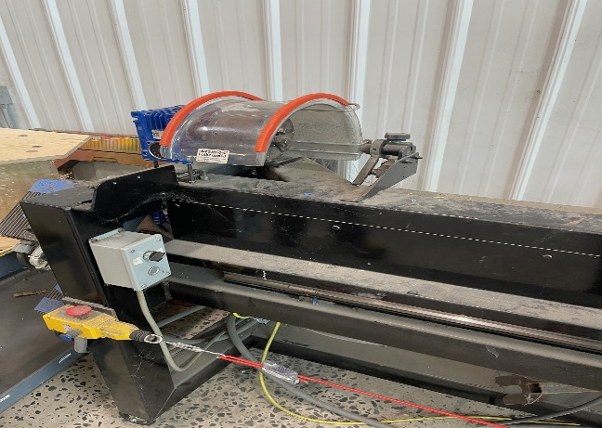

Machine Name/Department | Drill Press / Maintenance
Existing Safeguards | Point Of Operation Cover
Risk/Observations | No Deficiencies Noted
Recommendation(s) | No Formal Recommendations
Machine/Hazard
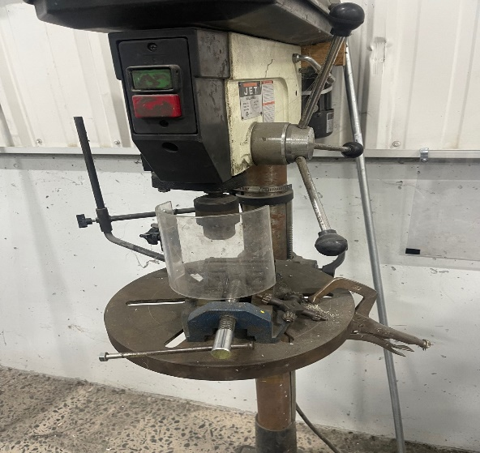

Machine Name/Department | Dewalt Chop Saw / Maintenance
Existing Safeguards | Manufacturer Installed Guards
Risk/Observations | No Deficiencies Noted
Recommendation(s) | No Formal Recommendations
Machine/Hazard
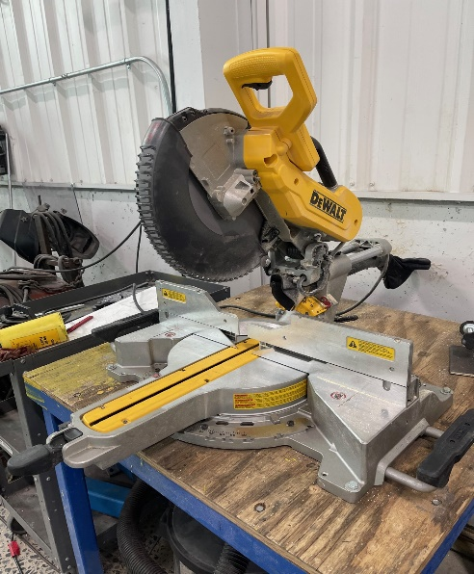

Machine Name/Department | Flex 4.5” Angle Grinder / Maintenance
Existing Safeguards | Manufacturer Installed Grinder Guard
Risk/Observations | No Deficiencies Noted
Recommendation(s) | No Formal Recommendations
Machine/Hazard
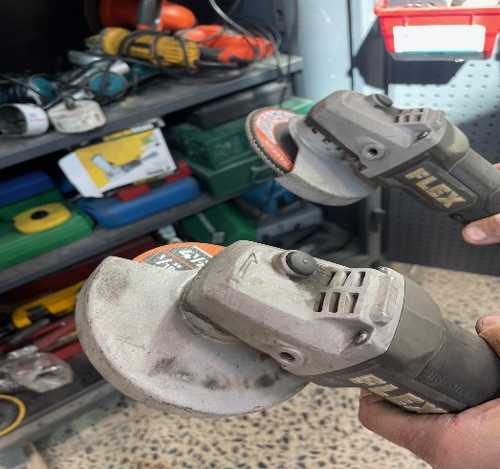

Machine Name/Department | Dewalt 4.5” Grinder / Maintenance
Existing Safeguards | Manufacturer Installed Grinder Guard
Risk/Observations | No Deficiencies Noted
Recommendation(s) | No Formal Recommendations
Machine/Hazard
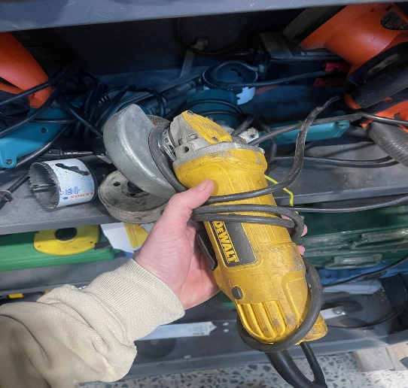

Machine Name/Department | Kobalt Table Saw / Maintenance
Existing Safeguards | Manufacturer Installed Guards
Risk/Observations | No Deficiencies Noted
Recommendation(s) | No Formal Recommendations
Machine/Hazard
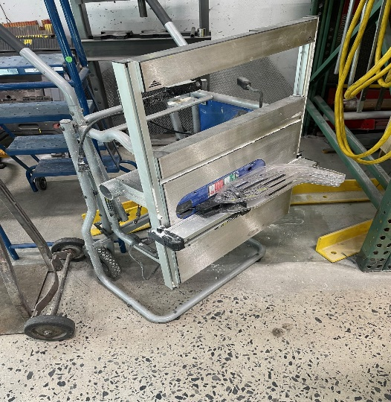

Machine Name/Department | Central Hydraulics 20 Ton Bottle Jack / Maintenance
Existing Safeguards | None Noted
Risk/Observations | No Deficiencies Observed
Recommendation(s) | No Formal Recommendation
Machine/Hazard
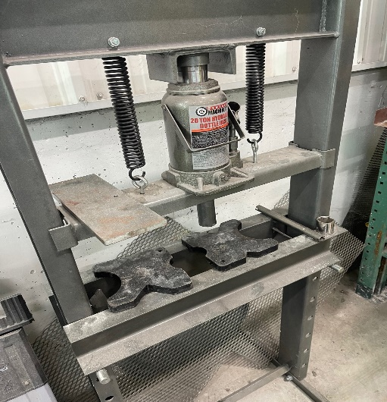

Machine Name/Department | Re-Master
Existing Safeguards | Door Interlocks, Protective Barriers/ Glass walls
Risk/Observations | No Deficiencies Observed
Recommendation(s) | No Formal Recommendation
Machine/Hazard | Door Interlock/Protective Barrier
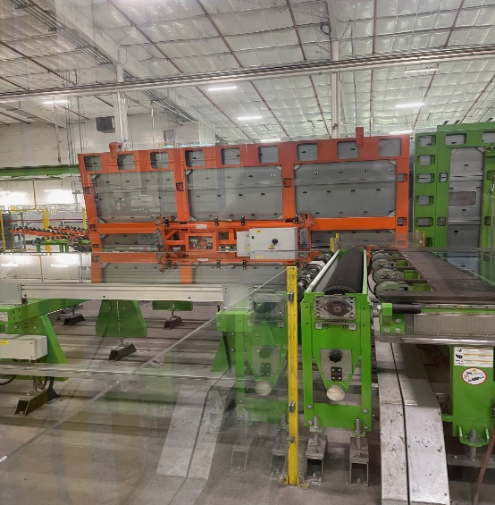 | 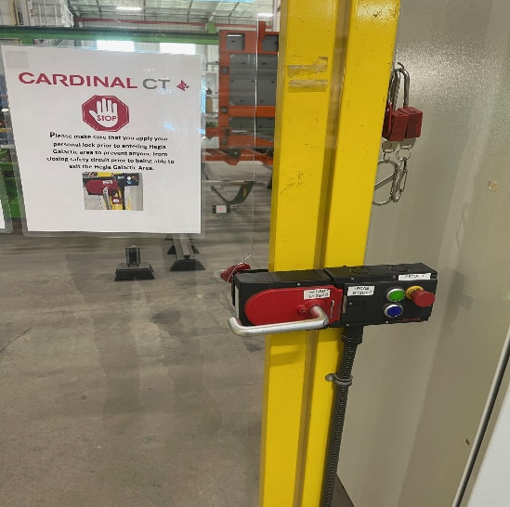

Machine Name/Department | Line #1 Breakout
Existing Safeguards | Emergency E-Stops, Safety Cable
Risk/Observations | No Deficiencies Observed
Recommendation(s) | No Formal Recommendation
Machine/Hazard | E-stop/Safety cable/Conveyor guarding
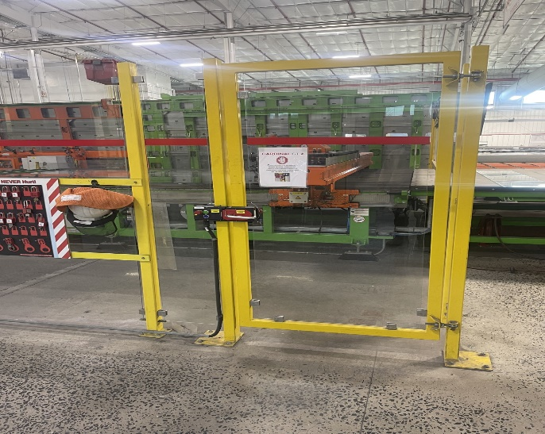 | 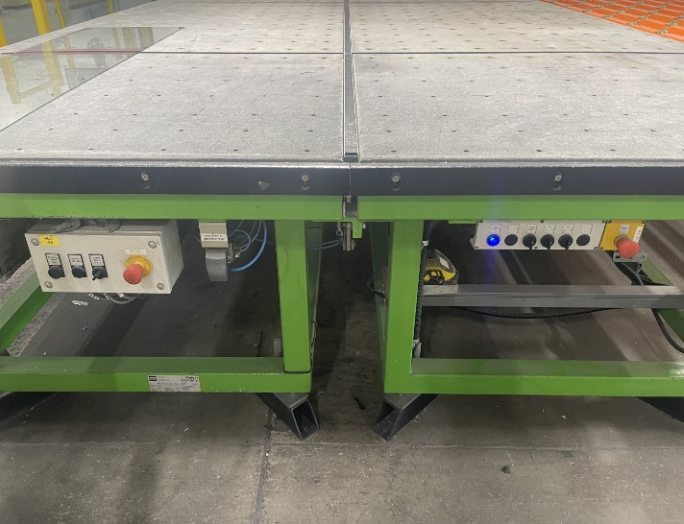
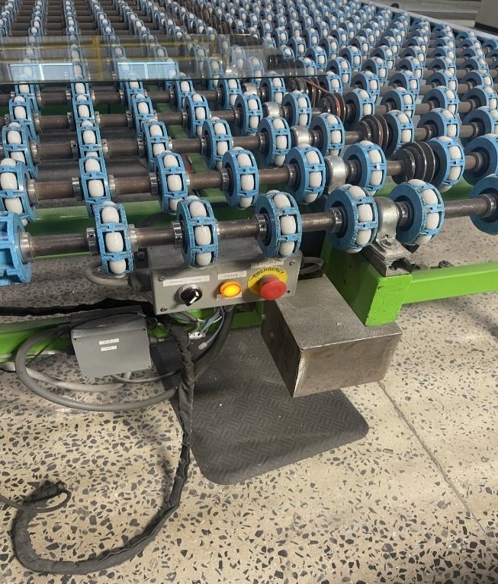 | 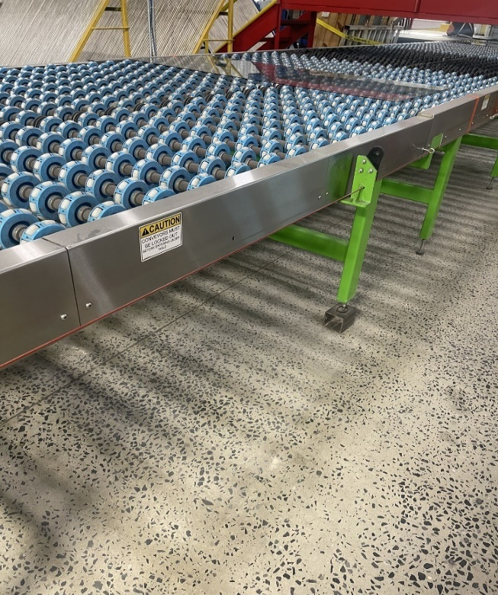

Machine Name/Department | Line #1 Seamer
Existing Safeguards | Emergency E-Stop, Guarding, Guard rail
Risk/Observations | No Deficiencies Observed
Recommendation(s) | Ensure Guarding Remains In Place
Machine/Hazard | Machine Guarding/E-stops
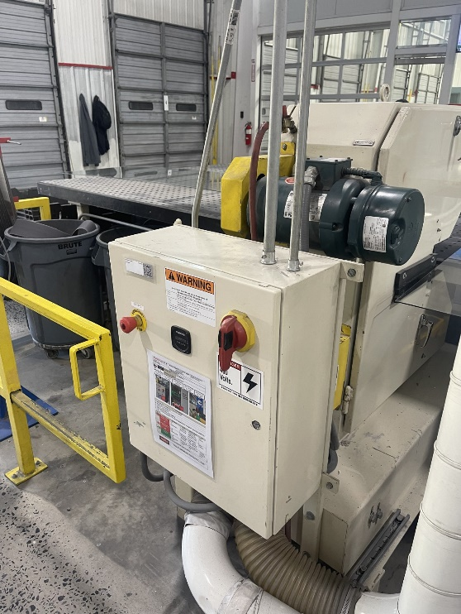 | 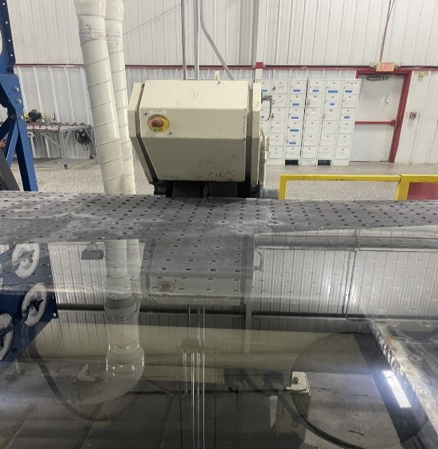

Machine Name/Department | Line #1 Washer
Existing Safeguards | Guarding Covering Pulleys, Emergency Stop
Risk/Observations | None Observed
Recommendation(s) | No Formal Recommendations
Machine/Hazard | Machine Guarding/E-Stop
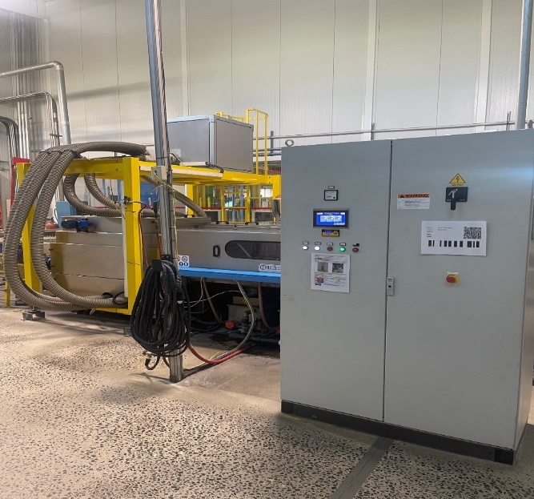 | 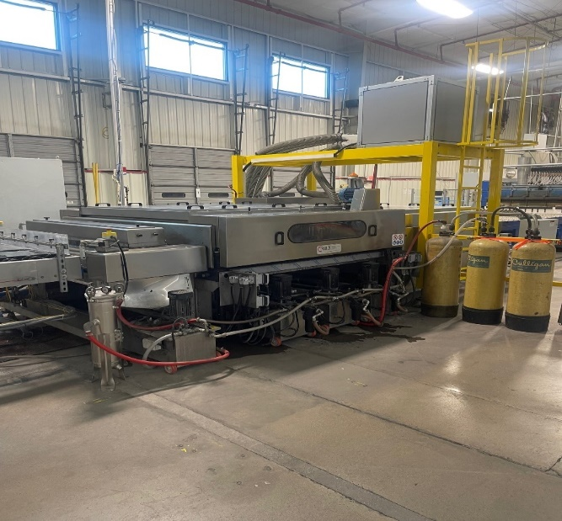

Machine Name/Department | Line #1 Furnace
Existing Safeguards | Side Guards and glass walls Covering Mechanical Motion
Risk/Observations | Short side guards ( can reach from underneath)  Part of guard doesn’t match the rest and has sharp edges close to the washer.
Recommendation(s) | Side Guards covering rotating parts need to be extended down to help protect from the possibility of reaching underneath and getting caught in the shaft.  Also need to replace small section of guarding that doesn’t match the rest and has sharp edges close to the washer.
Machine/Hazard | Machine Guarding
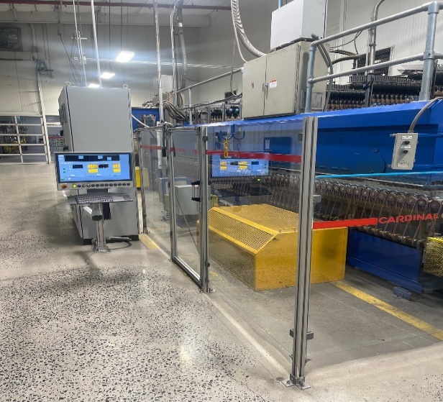 | 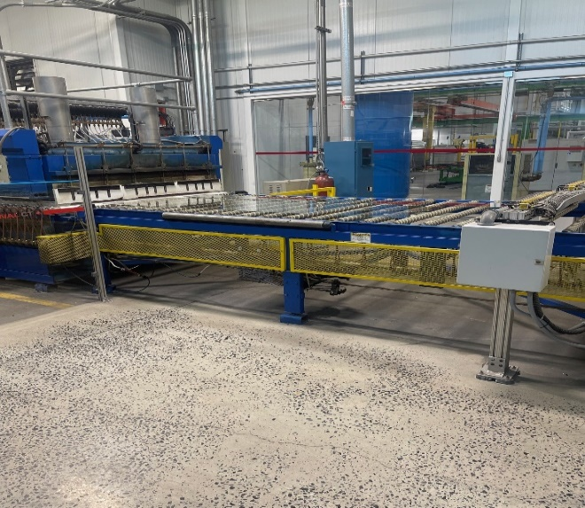

Machine/Department | Line #1 Quench
Existing Safeguards | Guarding Covering Pulleys & Belts, Emergency Stop
Risk/Observations | Part of guarding where glass walls meet yellow quench guards are bent.
Recommendation(s) | Replace section of bent guards with new more sturdy section of guards
Machine/Hazard | Machine Guarding/E-Stop
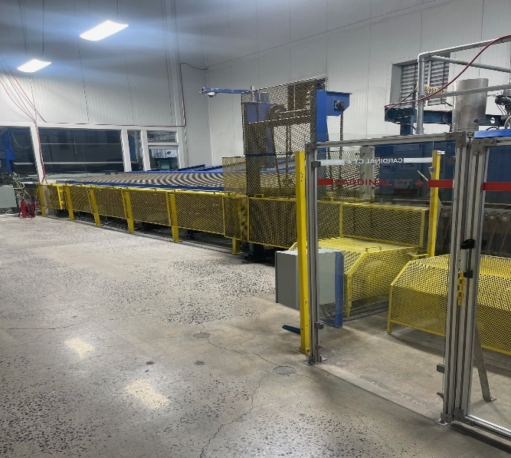 | 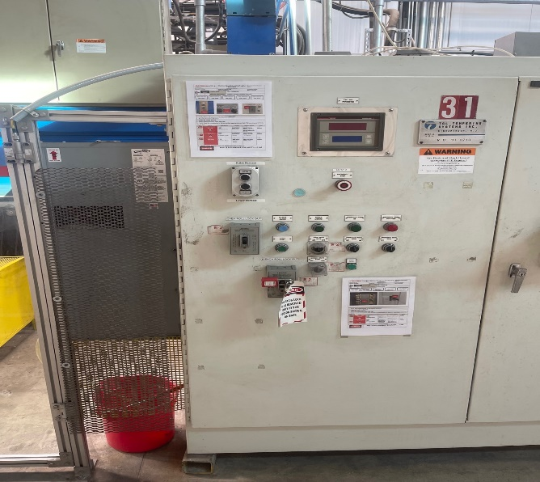

Machine Name/Department | Line #1 Offload
Existing Safeguards | Guarding, Emergency Stop, Push Button
Risk/Observations | Short side guards, can reach underneath it and grab rotating shaft.
Recommendation(s) | Extend side guards down so shaft can not be reached.
Machine/Hazard | Machine Guarding/E-Stop/Push Button
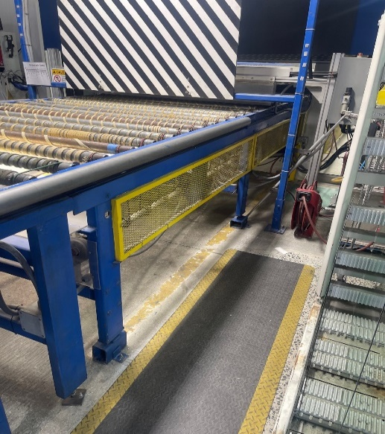 | 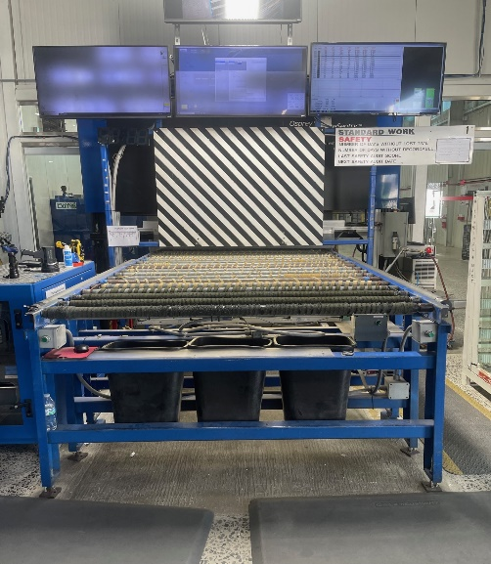

Machine Name/Department | Line #1 Blower Room
Existing Safeguards | Machine Guarding
Risk/Observations | Exposed Hydraulic Lifting Arms
Recommendation(s) | Apply some type of machine guarding to cover Hydraulic lifting arms.
Machine/Hazard | Machine Guarding/E-Stop/Push Button
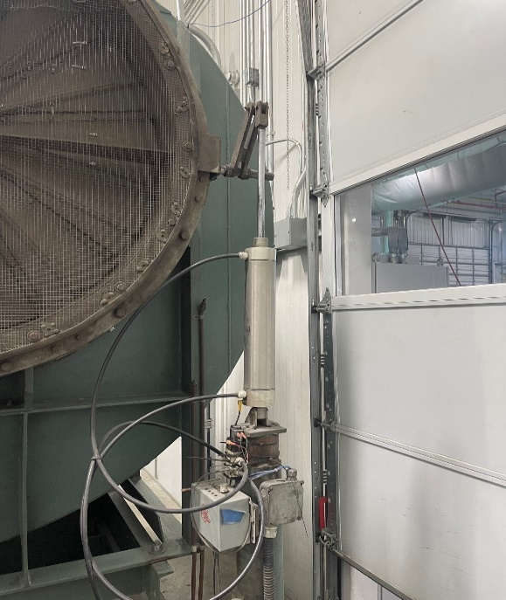 | 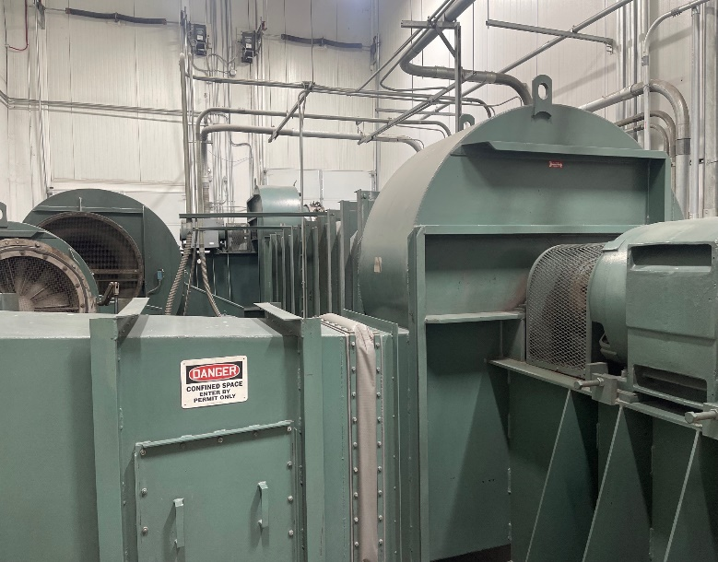

Machine Name/Department | Line #1 Dust Collector
Existing Safeguards | Manufacturer Installed Guards
Risk/Observations | No Deficiencies Observed
Recommendation(s) | No Formal Recommendations
Machine/Hazard | Manufacturer Machine Guarding
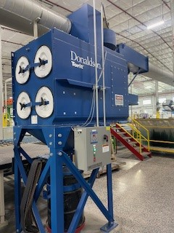 | 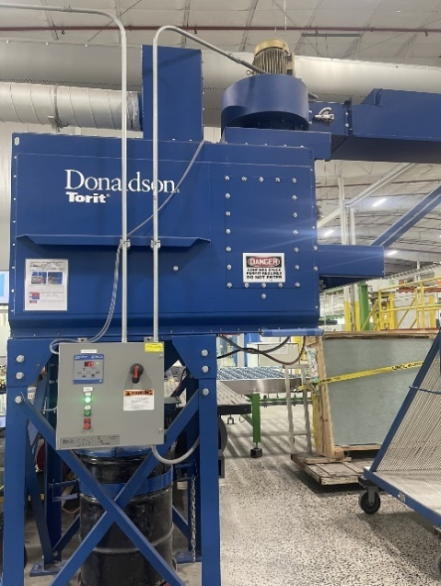

Machine Name/Department | Line #3 Breakout
Existing Safeguards | Emergency Stop, Safety E-stop Cable, Door Interlocks, Glass walls
Risk/Observations | Worn ergonomic roller wheel
Recommendation(s) | Replace wheel so there will be less chance of glass breaking on contact.
Machine/Hazard | E-Stop/Safety Cables/Door interlock/Glass walls
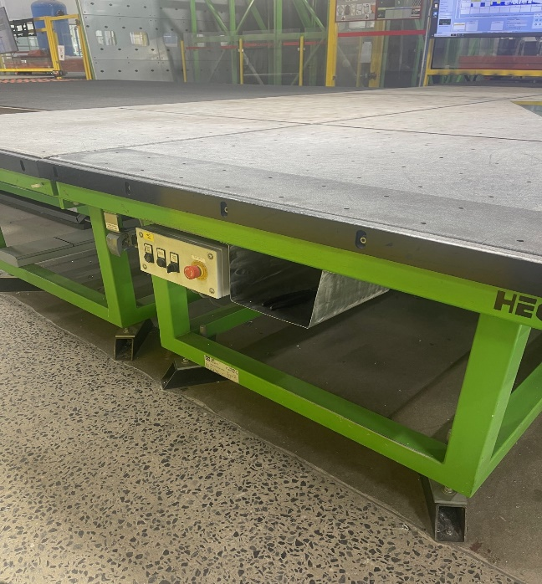 | 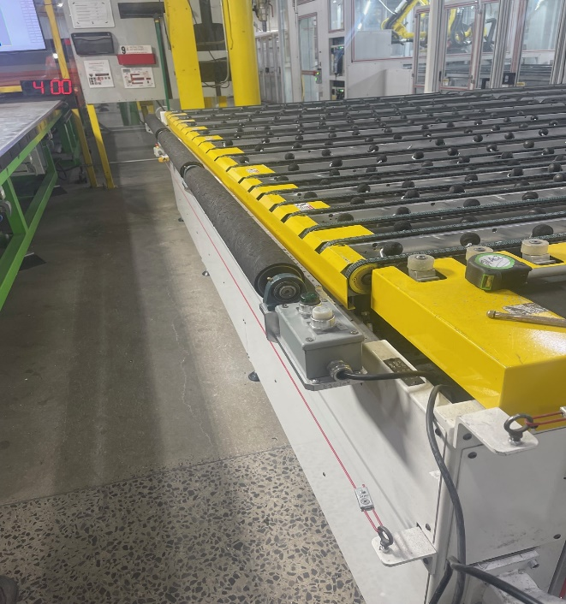
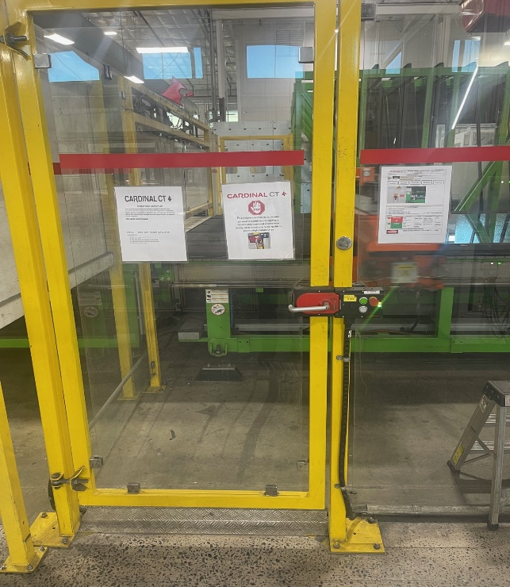

Machine Name/Department | Line #3 Seamer
Existing Safeguards | Machine Guarding & Emergency Stop
Risk/Observations | No Deficiencies Observed
Recommendation(s) | No Formal Recommendations
Machine/Hazard | Machine Guarding/E-Stop
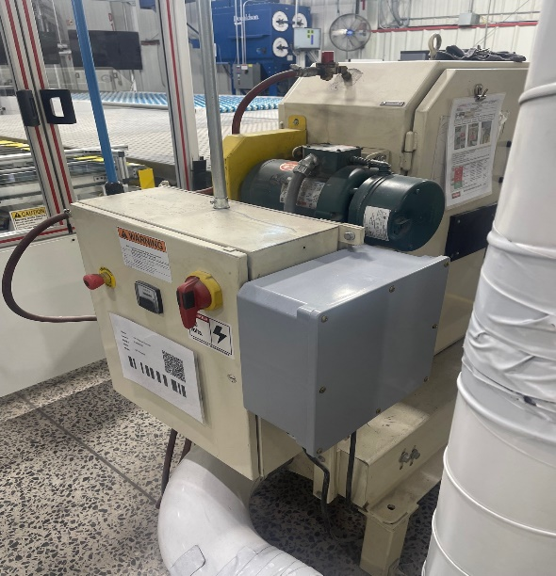 | 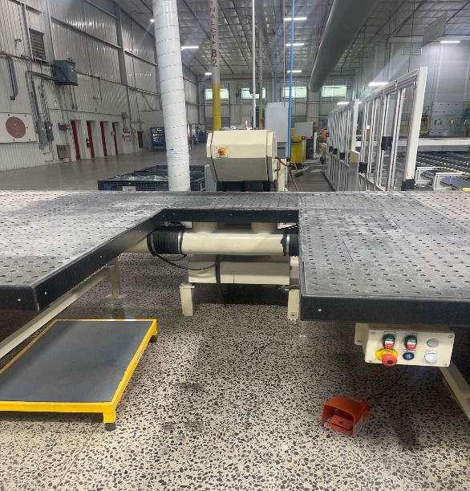

Machine Name/Department | Line #3 Oseam / Conveyor
Existing Safeguards | Machine Guarding, Protective Barriers, Door Interlocks, E-stops
Risk/Observations | No Deficiencies Observed
Recommendation(s) | No Formal Recommendations
Machine/Hazard | Guarding/E-stops/Door interlocks/Glass walls
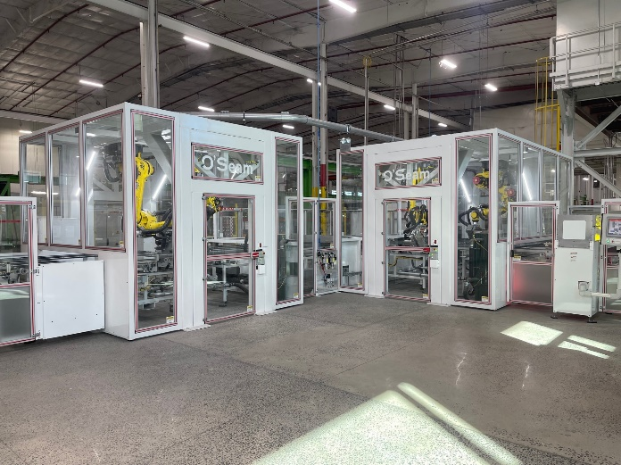 | 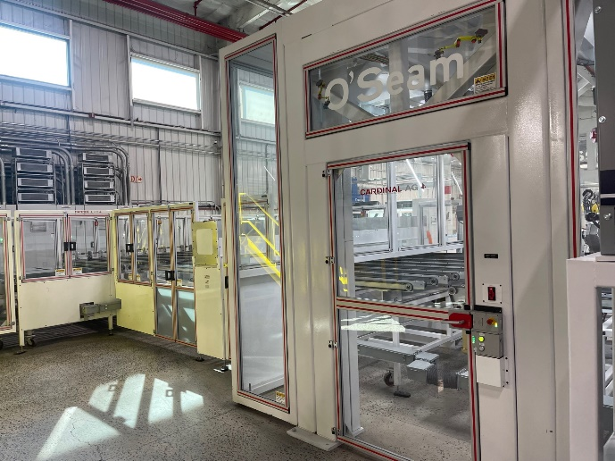

Machine Name/Department | Line #3 AG Conveyor
Existing Safeguards | Machine Guarding, Protective Barriers, Door Interlocks, E-stop, E-stop safety cable
Risk/Observations | No Deficiencies Observed
Recommendation(s) | No Formal Recommendations
Machine/Hazard | Guarding/E-stop/Safety Cable/Glass walls/Interlocks
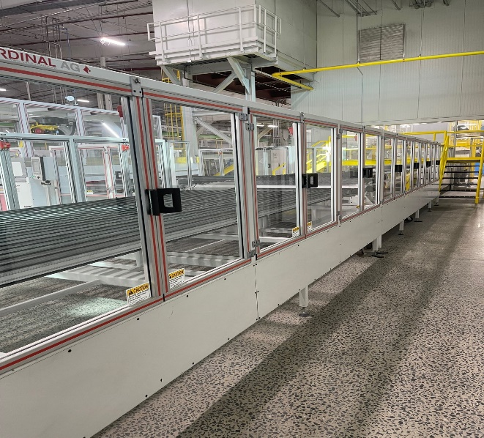 | 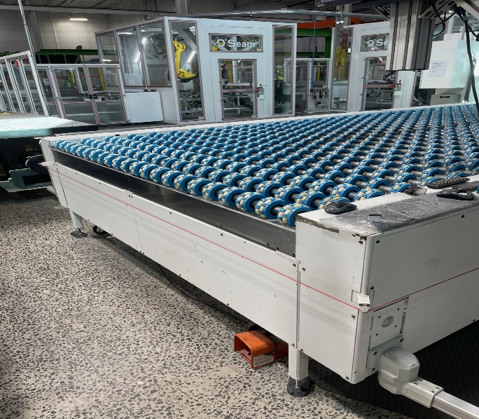

Machine Name/Department | Line #3 Washer
Existing Safeguards | Machine Guarding & Emergency Stop
Risk/Observations | No Deficiencies Observed
Recommendation(s) | No Formal Recommendations
Machine/Hazard | Machine Guarding/E-Stop
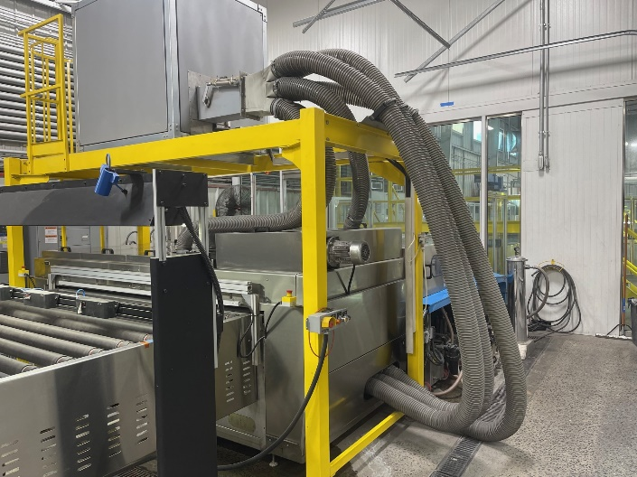 | 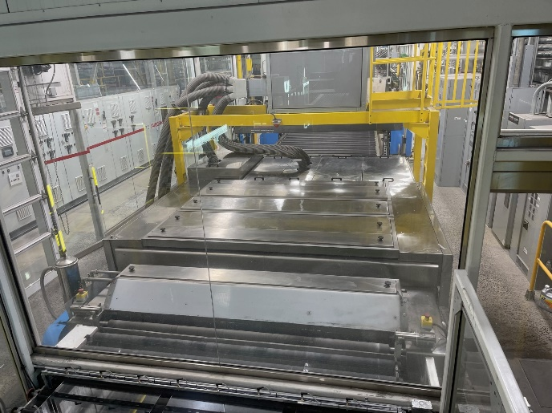

Machine Name/Department | Line #3 Furnace
Existing Safeguards | Machine Guarding, Emergency Stop
Risk/Observations | Pinch Points at furnace entrance
Recommendation(s) | Possibly get some type of machine guarding for the furnace entrance
Machine/Hazard | Machine Guarding/E-Stop
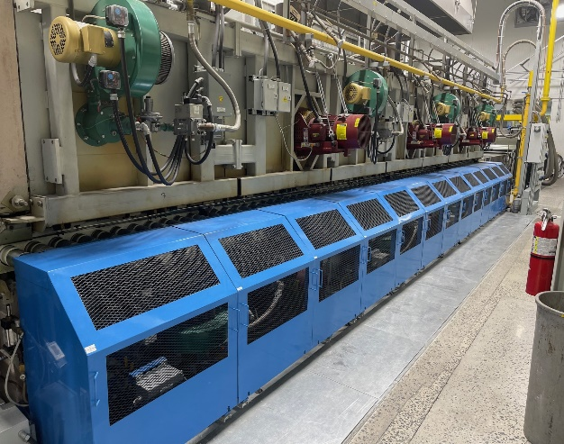 | 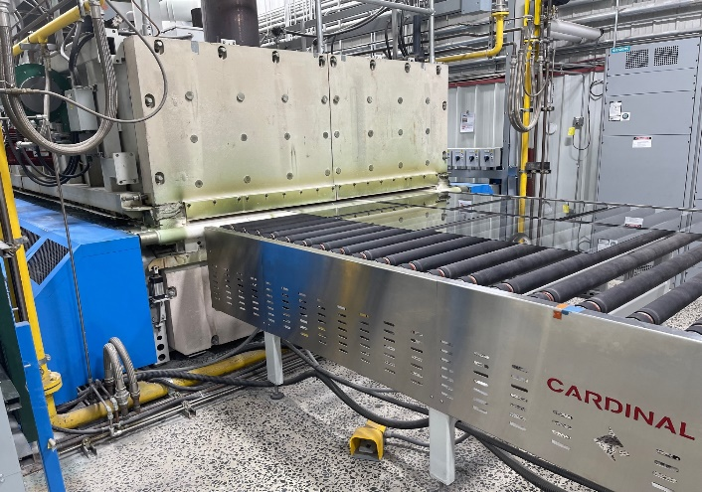

Machine Name/Department | Line #3 Quench
Existing Safeguards | Machine Guarding, E-stop
Risk/Observations | Exposed hydraulic shaft
Recommendation(s) | Apply some type of guarding to protect pinch point while quench is being raised and lowered.
Machine/Hazard | Machine Guarding
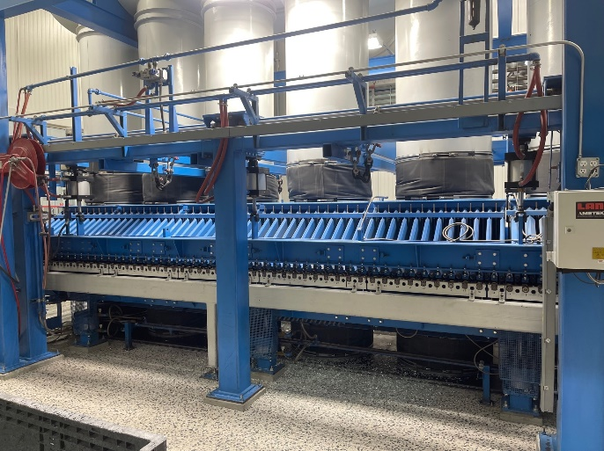 | 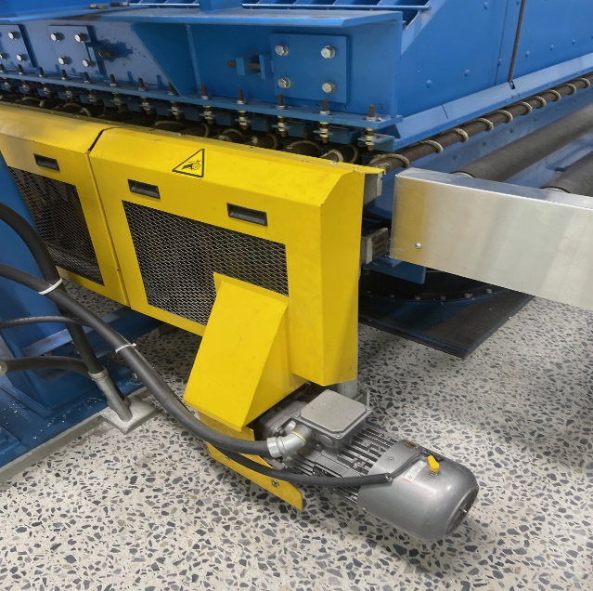

Machine Name/Department | Line #3 Offload
Existing Safeguards | Emergency Stop, Machine Guarding
Risk/Observations | No Deficiencies Observed
Recommendation(s) | No Formal Recommendations
Machine/Hazard | E-Stop
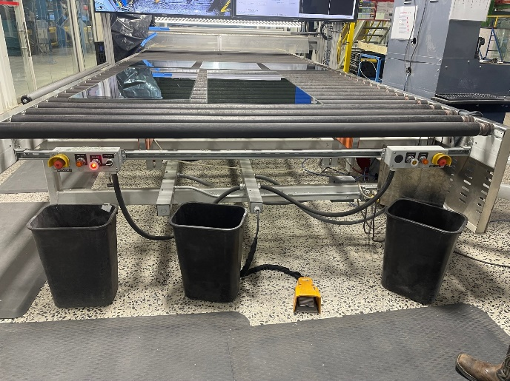 | 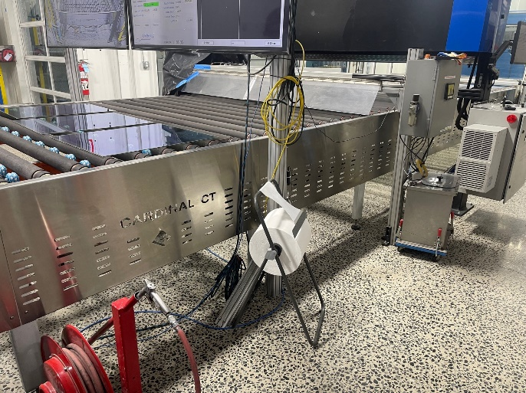

Machine Name/Department | Line #3 Blower Room
Existing Safeguards | Machine Guarding
Risk/Observations | Exposed Hydraulic Lifting Arms
Recommendation(s) | Apply some type of machine guarding to cover Hydraulic lifting arms.  Or possibly restrict entry to blower room to authorized employees (Maintenance) only.
Machine/Hazard
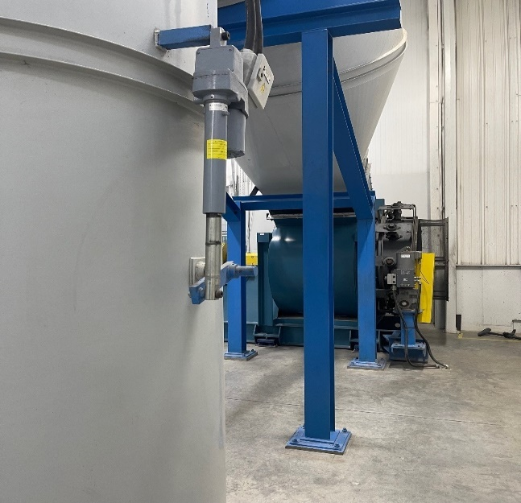 | 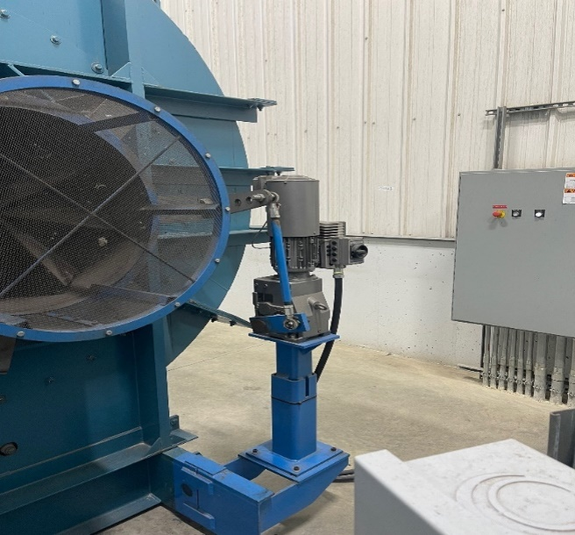

Machine Name/Department | Line #3 Dust Collector ( Manual and O’seam)
Existing Safeguards | Manufacturer Installed Guarding
Risk/Observations | No Deficiencies Noted
Recommendation(s) | No Formal Recommendations
Machine/Hazard
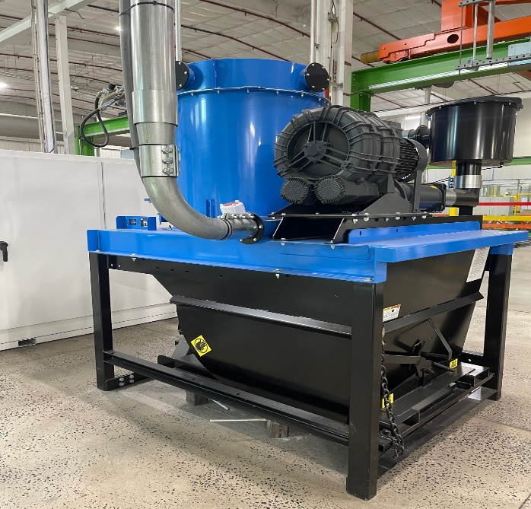 | 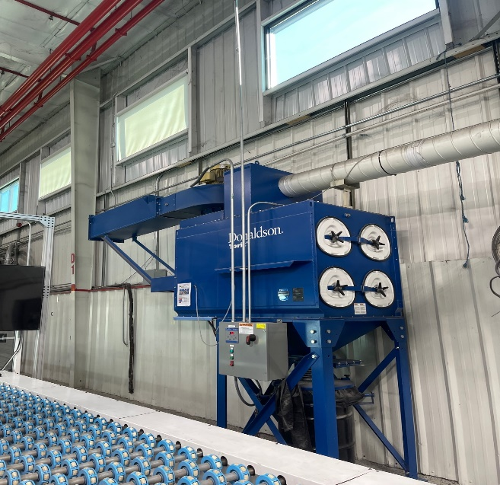

Machine Name/Department | Lami Cutter
Existing Safeguards | Emergency Stop/Foot Pedal/Guarding
Risk/Observations | No Deficiencies Observed
Recommendation(s) | No Formal Recommendations
Machine/Hazard
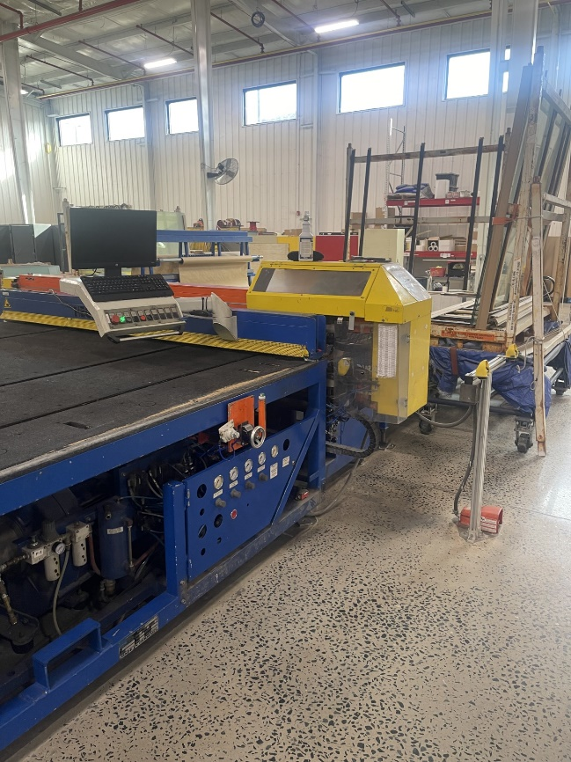 | 