SAFETY Word Search November 2023

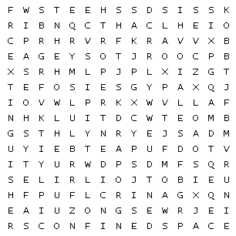

|  |  |  |  |  |  |  |
| --- | --- | --- | --- | --- | --- | --- |
| Carolina Star |  | Confined space |  | extinguisher | |  |
| Fall |  | Fire |  | gloves | |  |
| Incident report |  | JSA |  | PPE | |  |
| Safety shoes |  | SDS sheets |  | sharps | |  |
| Slip |  | Trip |  |  | |  |
| Extinguisher | | Gloves |
|  | |  | fire |  | gloves |  |
|  | |  | JSA |  | PPE |  |
|  | |  | SDSsheets |  | sharps |  |