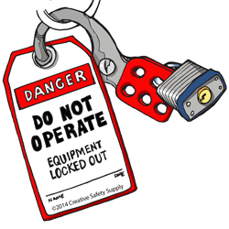 | ISOLATION POINTS |  | Process Area: |  |  | Line 3 Tempering
 | 2 |  | Machine Description: |  |  | Triulzi Washer
NEXT AUDIT DUE
February 2025

NEXT AUDIT DUE
February 2027

NEXT AUDIT DUE
February 2028

NEXT AUDIT DUE
February 2029
NEXT AUDIT DUE
February 2026

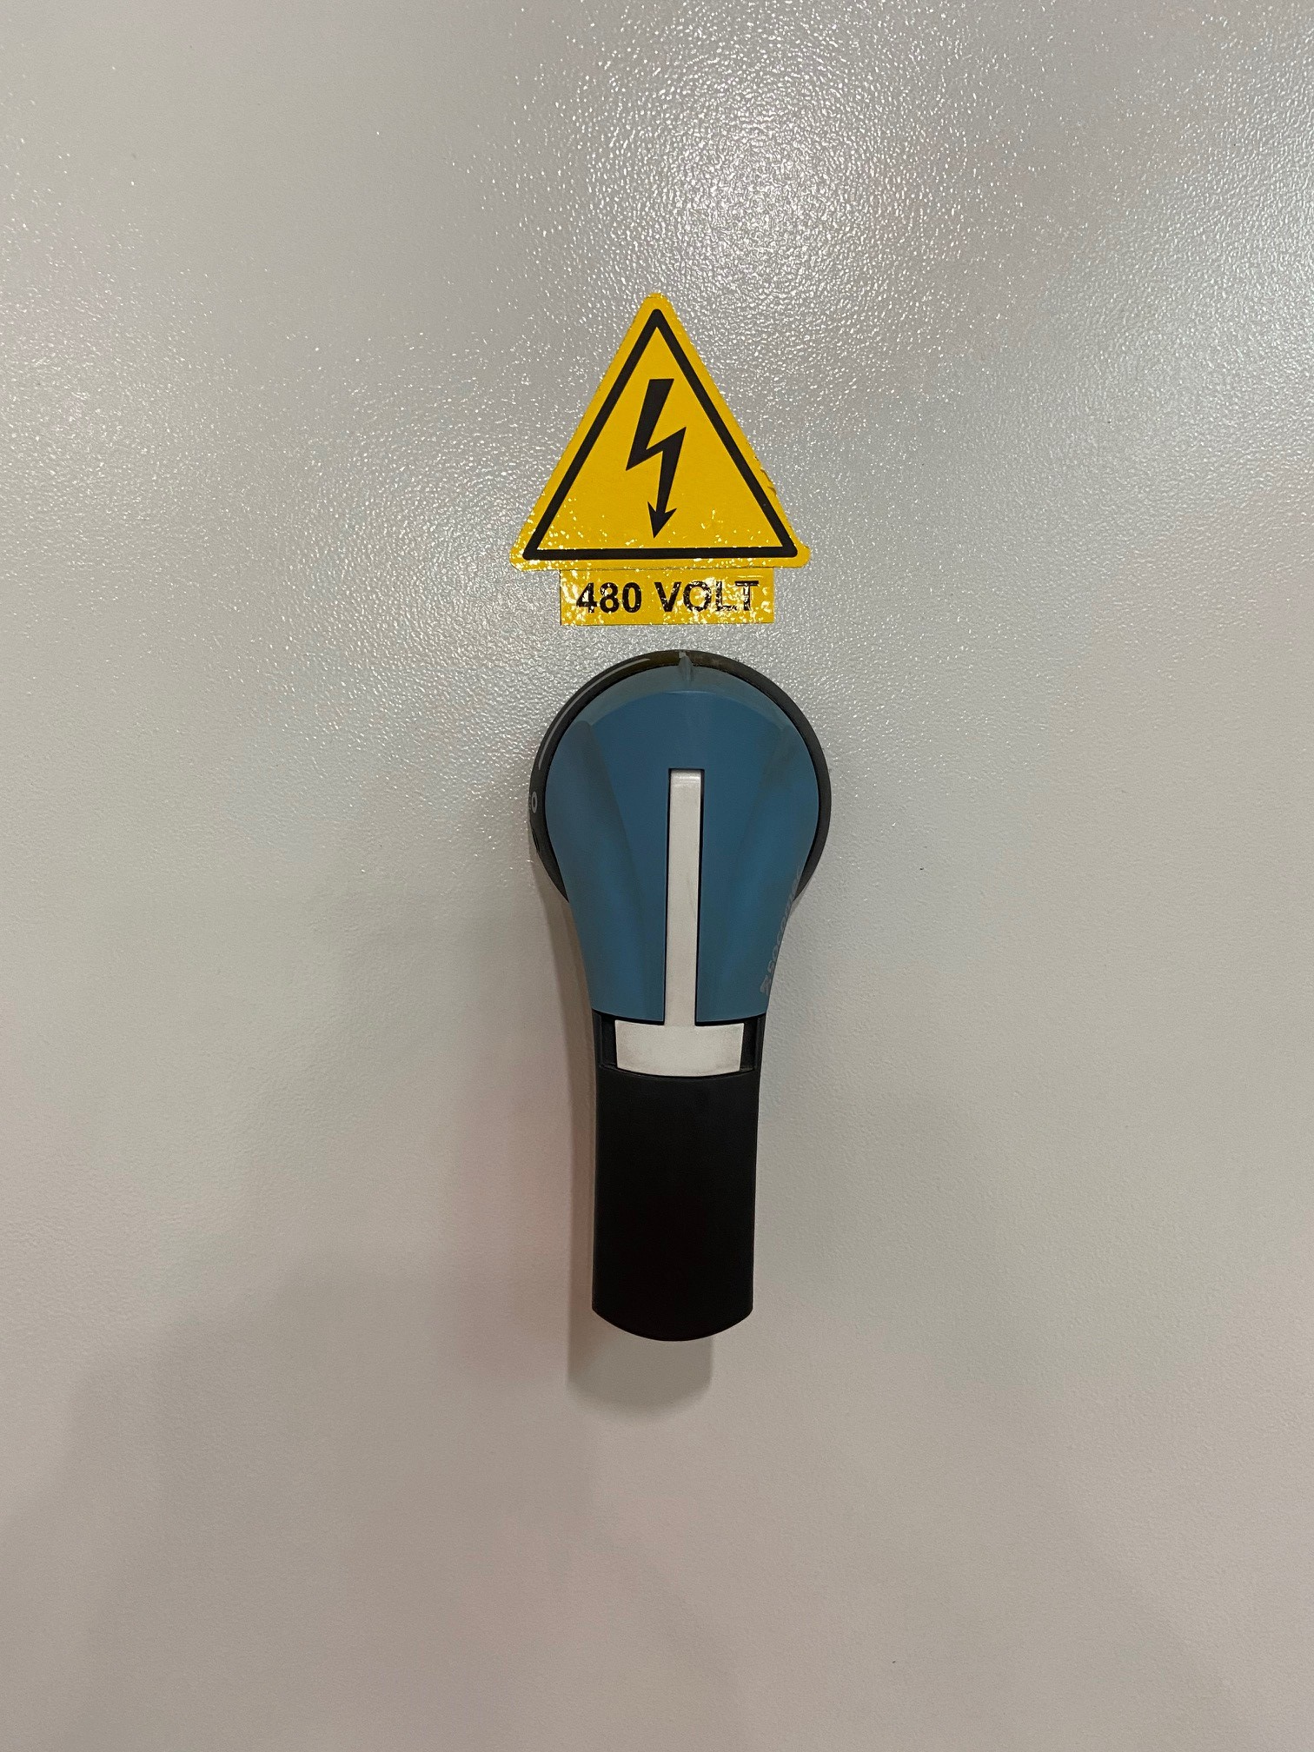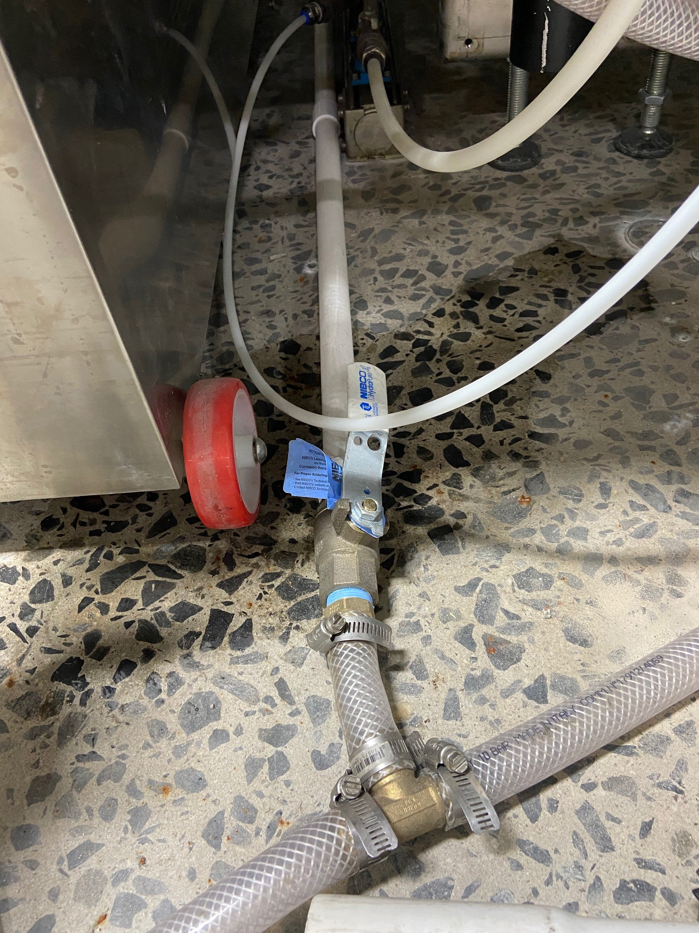
W-1
E-1
LOTO PROCEDURE
1 - Notify Affected Employees of the Machine LOCKOUT
2 - Properly Shut Down Machine
3 - Isolate All Energy Sources
4 - Apply Lockout devises, Locks, and Tags
5 – Verify Total De-energization of all sources (use appropriate arc flash PPE according to NFPA 70e standards)
ID |  | Source |  |  | LOTO Device |  | Location | Isolation Method | Verify
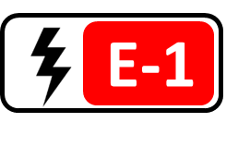 |  | PRIMARY SOURCE  Electrical (480 V)   |  |  | 1 Lock  1 Tag  1 Isolation Device |  | E-1 located on the operator side of the control panel | Turn disconnect switch E-1 to the “OFF” position and apply lock and tag. | Verify Isolation
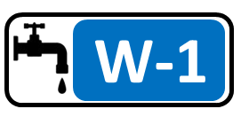 |  | Water Hazard  (Water Valve) |  |  | 1 Lock  1 Tag  1 Valve Isolation Device |  | W-1 located on the operator side of the control panel near the floor | Close water valve W-1 and apply valve isolation device lock and tag. | Check water line isolation.
6 - Notify affected employees once the equipment is safe to operate.
 |  |  |  | WHO IS RESPONSIBLE FOR SAFETY……I AM

LOCKOUT APPLICATION STEPS
# | Step | Instruction | Additional Information
1 | Notify Employees | Notify all affected employees that the machine or equipment will be shut down and locked out.
2 | Review Procedure | Ensure that each authorized employee understands the type and magnitude of the energy present, the associated hazards and the proper methods of control.
3 | Shutdown Equipment | If the machine or equipment is operating, shut it down by the normal stopping procedure.
4 | Isolate Energy | De-activate the energy isolating devices(s) so that the machine or equipment is isolated from the energy source(s).
5 | Lockout Controls | Lockout the energy isolating device(s) as indicated on the front of this procedure.
6 | Dissipate Energy | Dissipate any stored or residual energy as indicated on the front of this procedure.
7 | Verify Isolation | Verify that the energy source has been isolated as indicated on the front of this procedure.

LOCKOUT RELEASE STEPS
# | Step | Instruction | Additional Information
1 | Inspect Equipment | Check the equipment to ensure that the components are operationally intact.
2 | Check Area | Check the immediate area to ensure that all employees have been safely positioned, and that any nonessential items have been removed.
3 | Check Neutral | Verify that operating controls are in neutral.
4 | Re-Energize | Remove the lockout device(s) and activate the energy isolating device(s) to re-energize the equipment.
5 | Notify Employees | Notify affected employees that the servicing or maintenance is completed and the equipment is ready for use.
6 | Startup Equipment | Startup equipment and monitor for several operating cycles to ensure it is functioning properly.
Contact your supervisor or safety department if you have any questions or concerns about the accuracy or effectiveness of this procedure.

