
0N64 Heat Stress Management Program

Purpose: To educate, train and support employee partners exposed to the effects of heat stress in the workplace.
Goal: To reduce the risks associated with exposure to elevated seasonal temperatures.

Steps:
- Train employees to understand the effects of exposure to elevated temperatures (Heat Stress Days) for extended periods of time.
- Implement steps for employee partners and management to take during Heat Stress Days.
- Schedule Heat Audits by first aid responders and business management team members.

Key definitions:
Heat Stress Day - Any day calculated with the Heat Index Chart to be over 90° F.
Apparent Temperature - Factoring in the air temperature and humidity, what the temperature feels like on the human body. Also know as Heat Index.
Heat Audit – A survey of employee partners’ well-being by audit teams comprised of First Aid Responders and BMT members (see photo).

Summary
Through a program of education, training and mitigation, the effects of heat exposure can be managed, and risk of a heat stress event to our employee partners can be minimized. There are three parts to this program:
- Education/training
- Support
- Supervision
To mitigate the effects of exposure to elevated temperatures, every day with apparent temperatures over 90° F will automatically be designated a Heat Stress Day. It will be the responsibility of the Safety Coordinator to monitor the local weather forecast and alert the management team and department supervisors when a Heat Stress Day is declared. Employee partners also have four Heat Guage Stations located throughout the plant to help them monitor the apparent temperature in the plant. (see photo). All employees shall be informed of the location and significance of these stations with a One Point Lesson.

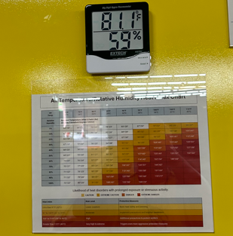
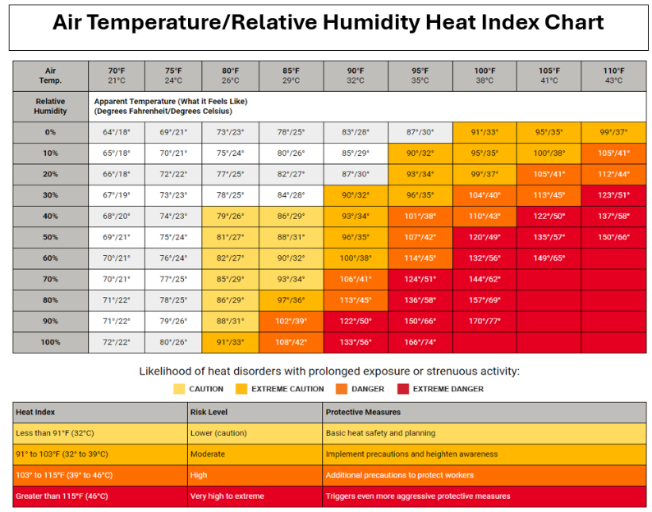

Education/Training:
It is imperative that all employees understand the effects of exposure to elevated temperatures for extended periods of time. With elevated apparent temperatures it becomes difficult for the body to maintain a core temperature that is safe to the human brain and body. Education will be done with timely Toolbox Talks leading into the summer months, and by employee engagement with first aid responders and management team members during Heat Audits, as well as in One Point Lesson pertaining to heat Gauge locations and how to use them to determine the apparent temperature.
Support
Branch 0N64 will provide employee partners with electrolyte drink packets, sealable cups, cooling towels, two ice and cold-water dispensers, an airconditioned breakroom with a chest freezer filled with complementary freeze pops, and four heat gauge stations with temp/humidity gauges and heat index charts. The Heat Audit Team will also have electrolyte freeze pops with them during the audit to distribute to anyone they observe in need of a refreshing electrolyte supplement.
Supervision
First Aid Responders and Management Team members will partner up to do two-man heat audits and to deliver freeze pops to every employee. The heat audits will give the teams the opportunity to evaluate employee partners for signs of heat stress and to take necessary first aid steps if necessary. The EHS Coordinator will make sure the audit team members know when they are to do audits, and make sure there are enough freeze pops available to service all employee team members.

Branch 0N64

